Lab | Type | Practical
LAB- 1 | A  A | To Revise the HTML concepts  - Make the table of the following design using HTML.  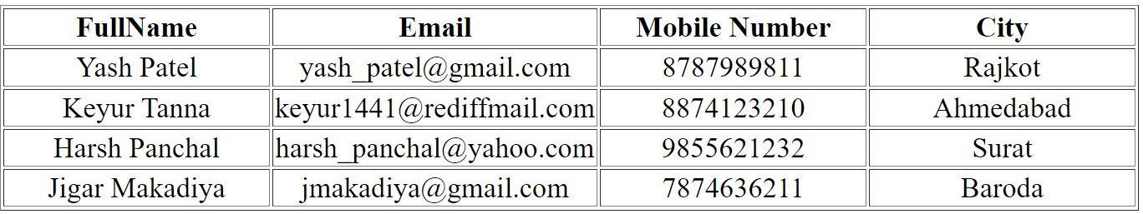  - Make the table of the following design using HTML.  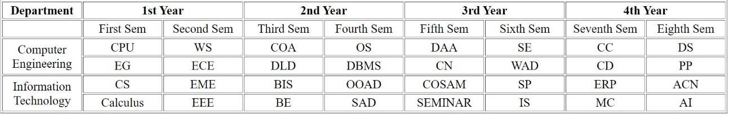

 | B | 3. Design Form of Student Registration, COVID-19 vaccine registration and Employee registration with following fields and also use HTML5 validation.  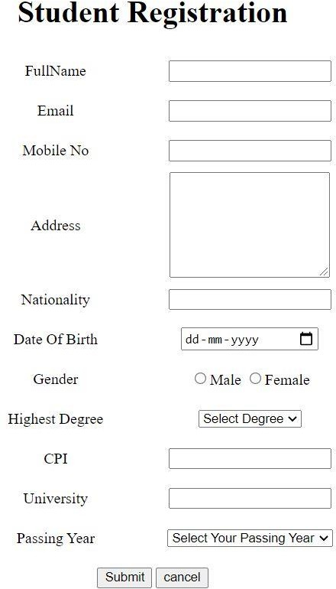

 | C | 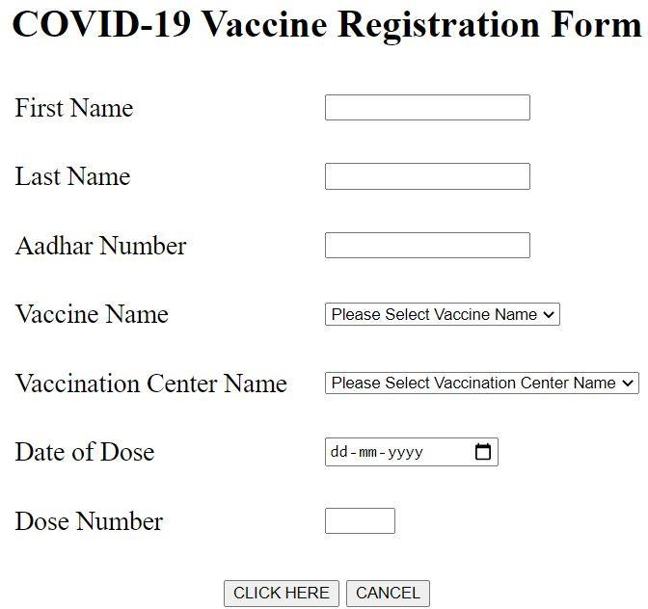

 |  | 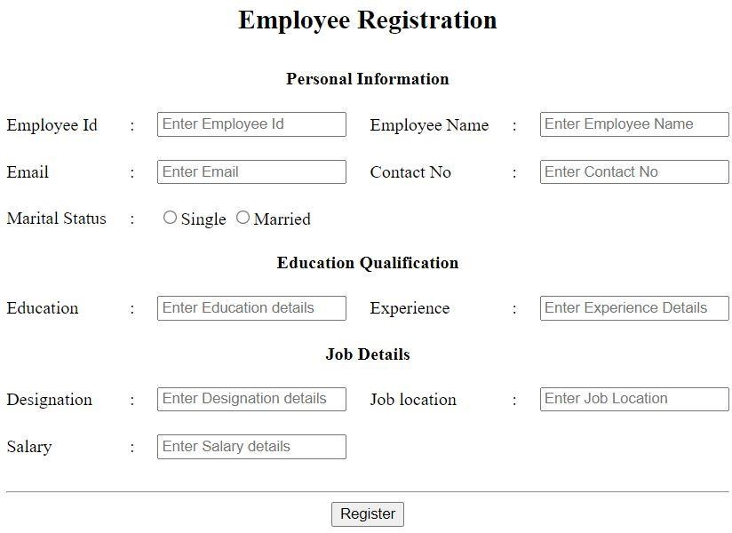
LAB- 2 | A  B  C | Design and develop the given pages using CSS properties.  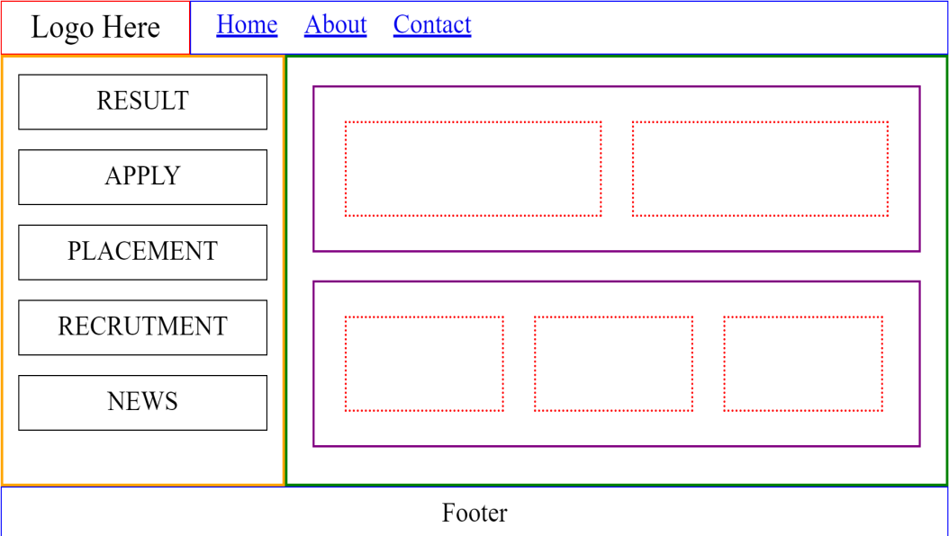  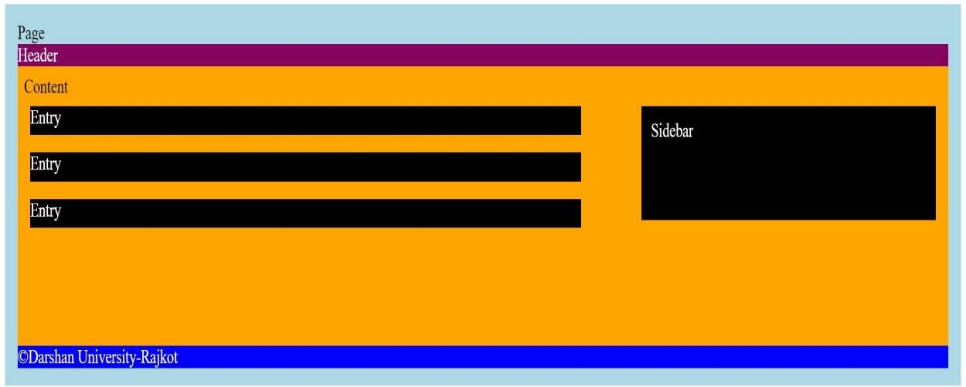  (The Link for the other layout for the practice will be shared)
LAB- 3 |  | Practice CSS selectors  1. Apply CSS to the practical no.1

LAB- 4 | A | Explore CSS properties for given pages  1. Design following pages using css  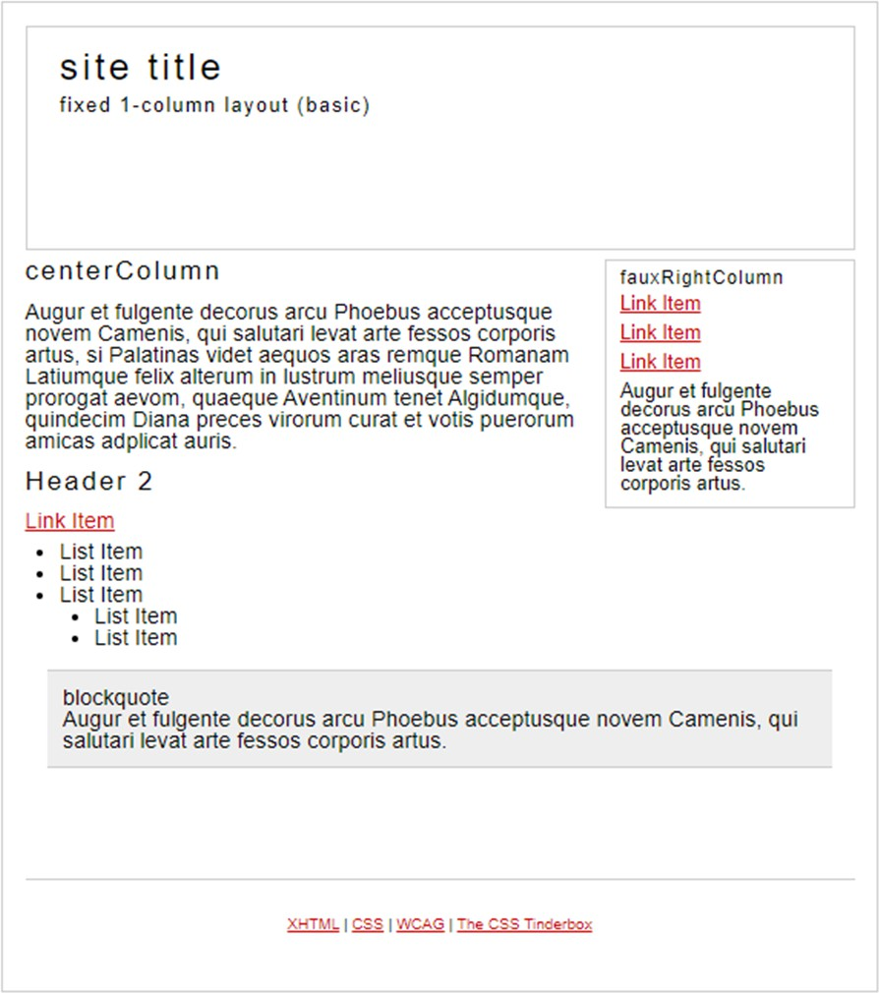

 | B | 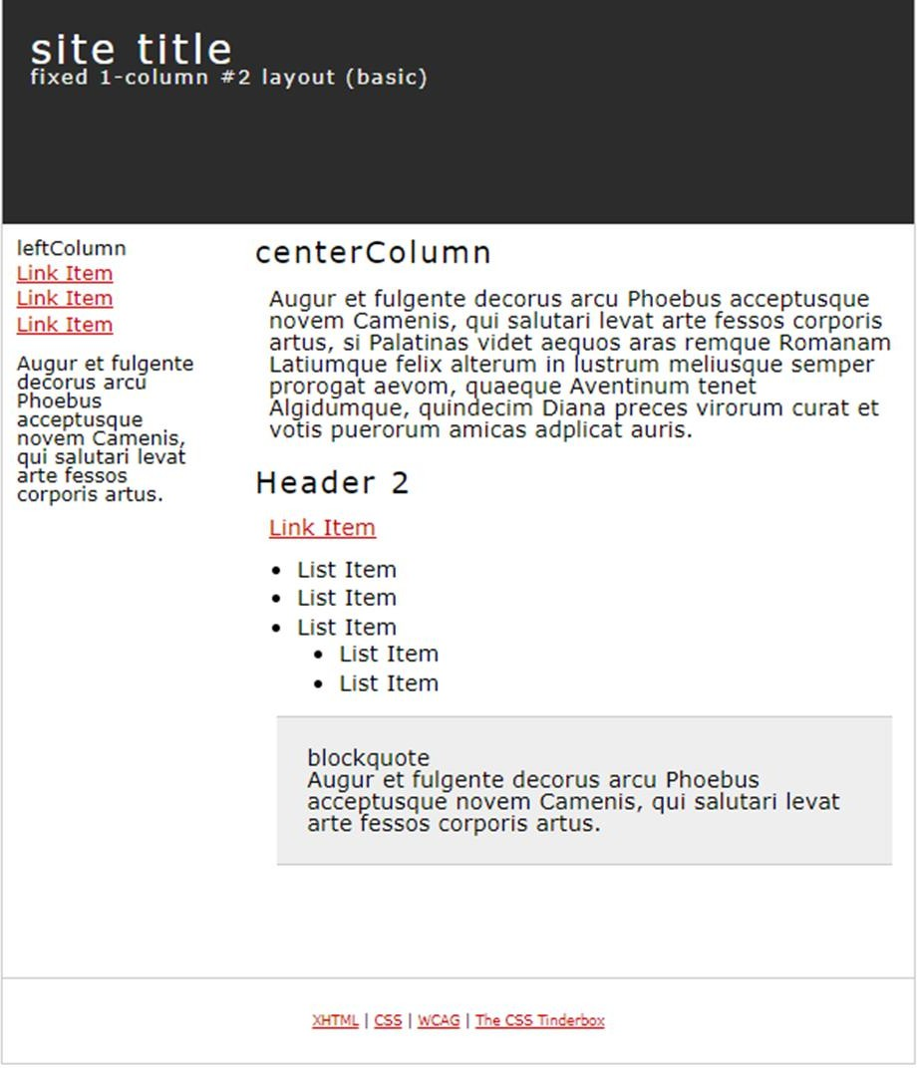

 | C | 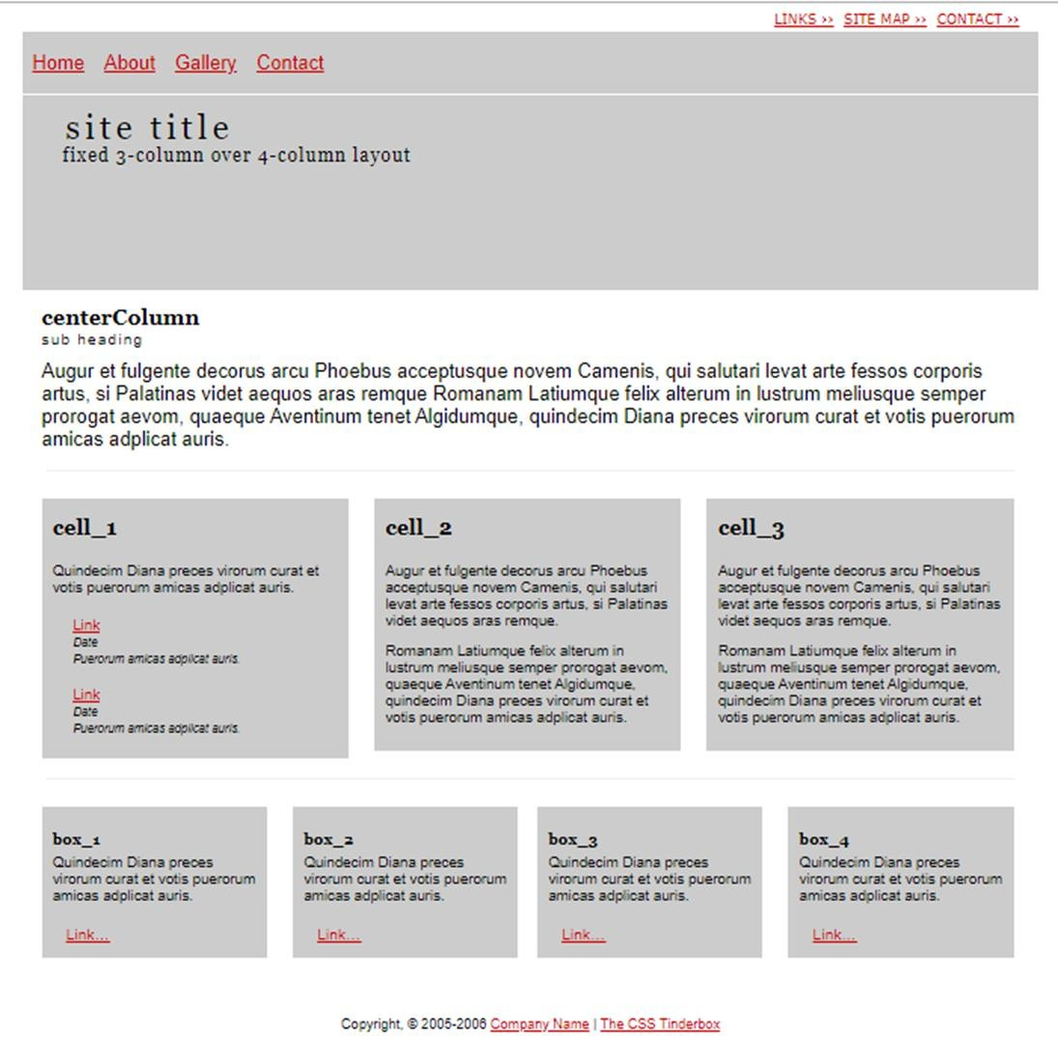

LAB- 5 | A  B C | To apply CSS for developing the following pages  - Build a Personal portfolio webpage using HTML and CSS.  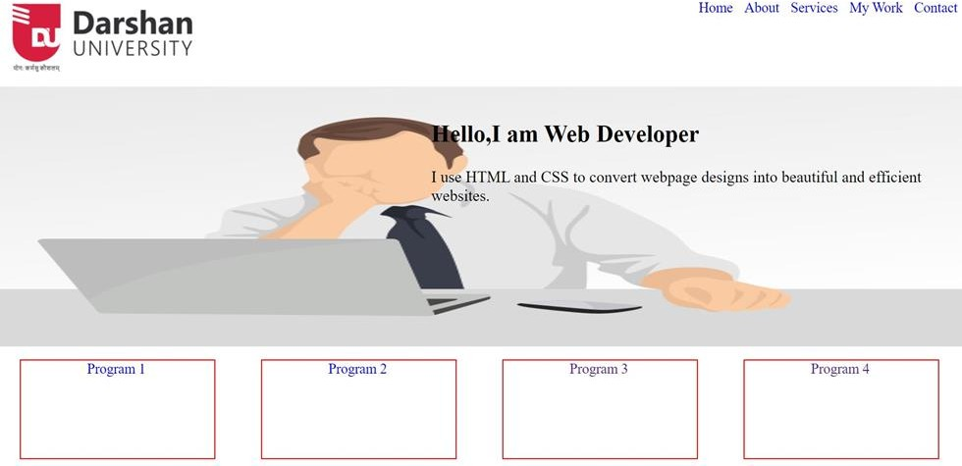  - Build a sample e-commerce website web page.  - Build a complete static website using HTML and CSS.
LAB- 6 | A B C | Design and develop web pages for the given animation effects  - changing background color of div from red to yellow.  - moving div from Left to right, right to bottom, bottom to left and left to top.  - put delay of 2s in animation.  - Change animation-iteration count property of program 2 to run infinite times  - Change animation direction property to run it in reverse order.  - Change value of animation-timing-function property to change the speed of animation
LAB- 7 |  | Apply media query on the given definitions  Note: Apply Media Queries on Practical No-4 and make it responsive.

LAB- 8 |  | To apply Gradient for the given definitions  - Demonstrate gradient in CSS.  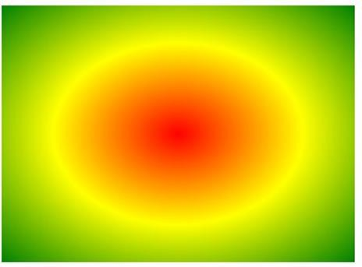  - Write an HTML snippet with CSS for following effects:  - Link after visited red color before visited orange color.  - Add special style(change color,font size etc) to first line of paragraph.  - Write an HTML snippet with CSS for following effects:  - Add special style (change color,font size etc) to first letter of paragraph  - Change background color to yellow when user select particular text  - Add special style to an element when user mouse over it.

LAB- 9 | A  B C | Apply typography and design responsive web pages      - Use Bootstrap typography to put abbreviation in paragraph.  - Use Bootstrap typography to align text (left, center, right)  - Create Unstyled list using Bootstrap typography.  - Use Bootstrap to display responsive image in webpage. Also use alignment to align it in left, center and right side of webpage.  - Use Bootstrap to create thumbnail of image.
LAB- 10 |  | Design and develop bootstrap Grid System  - Create a design similar to Practical No-4 using the grid system of bootstrap.

LAB- 11 | A  B | Design and develop the given pages using Bootstrap  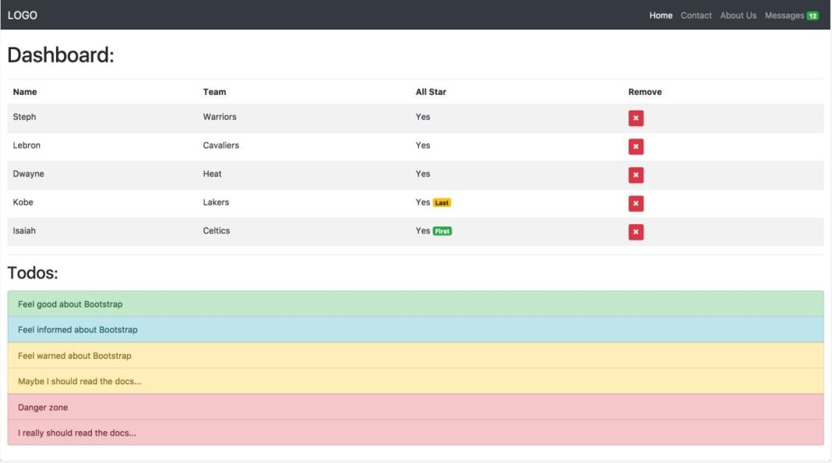  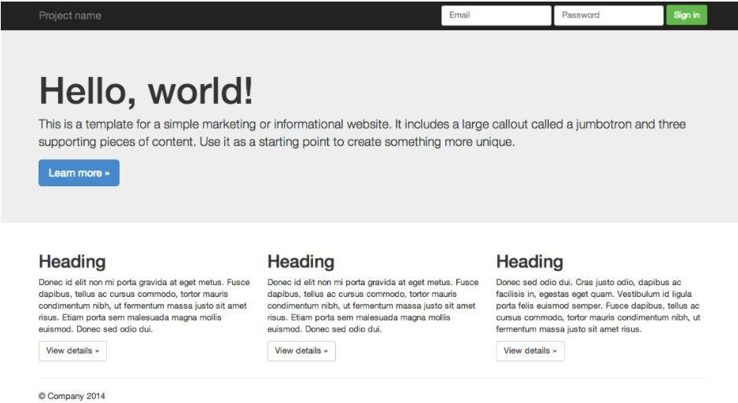

 |  | 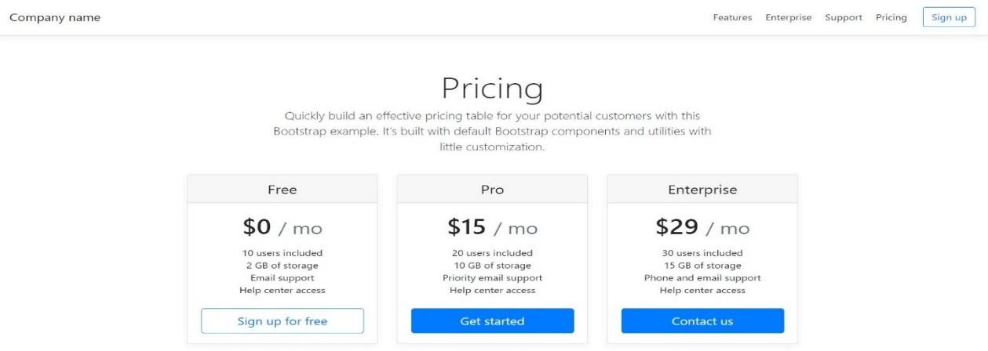
LAB- 12 | A  B | Design and Develop Bootstrap Forms  - ​  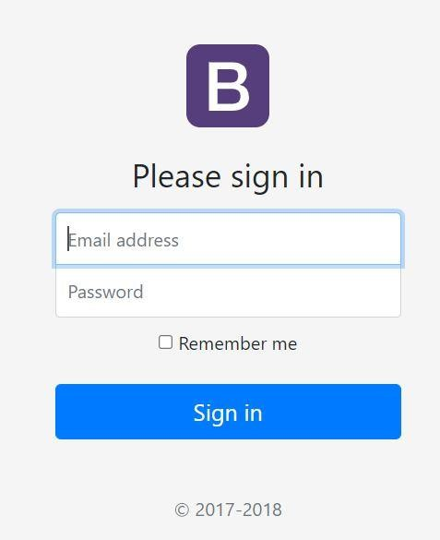  - Redesign forms created in Practical No-1 using Bootstrap

LAB- 13 | A  B  C | Explore responsive Bootstrap Forms for given pages  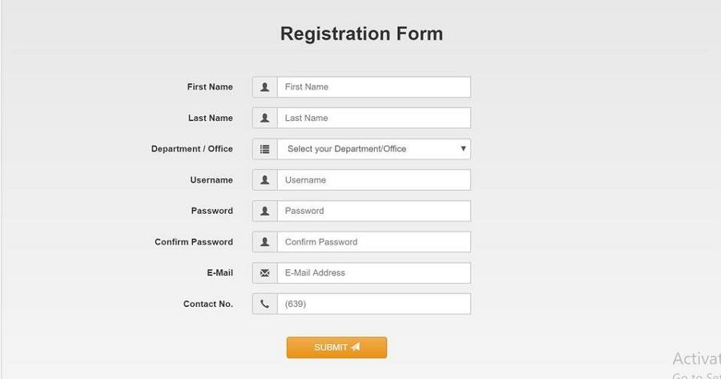  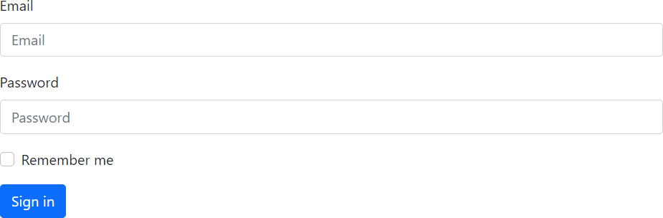  (The Link for the other layout for the practice will be shared)

